

NodeJS Task

**Student Name:   Pham Hong Phuc**

**Student ID:  001284212**

In this section of weekly report, I have learnt and practiced several attempts to comprehend Node.js uniqueness – the runtime environment that can diversify many webpages. Its versatility aid web developer to create such a distinct yet structural webpage format.

To start, integrated terminal of the folder is opened, then ‘npm init -y’ to define server.js file as a default file to run and debug.

Only one package to download as a library expansion to function the code: ‘npm install nodemon’. The utilization of a command line ‘nodemon {file_name}’ to debug the .js web files, consecutively.

The raw codes will be presented underneath:

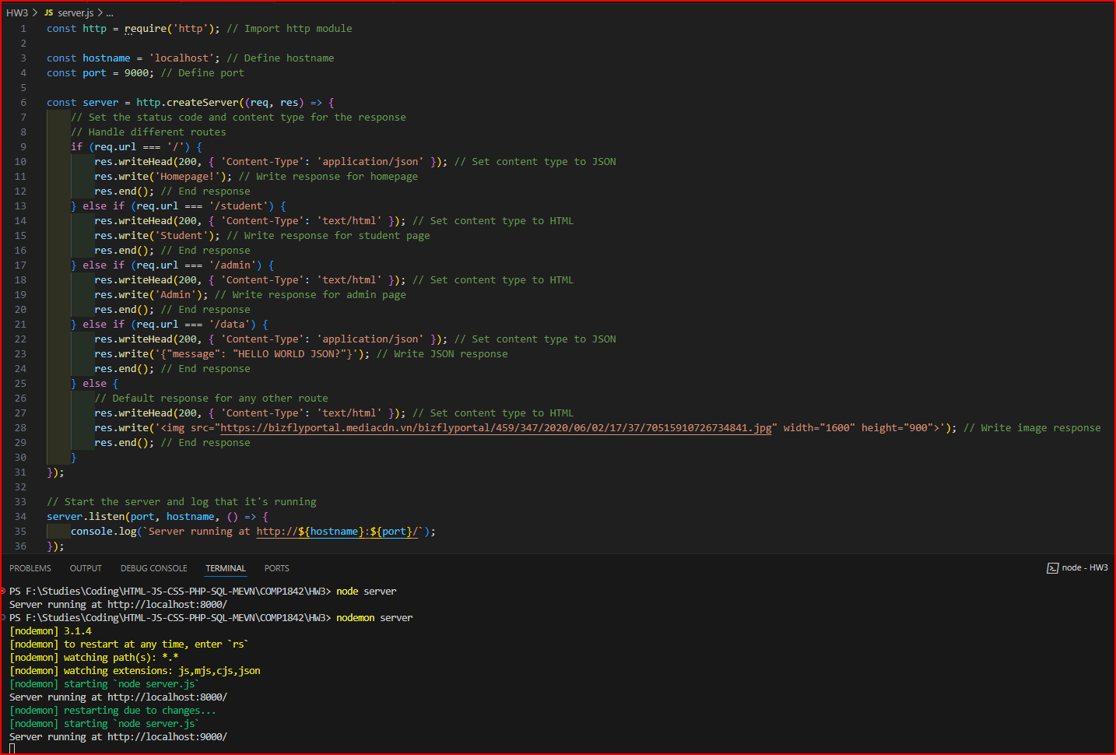

A variable is always needed to import, so we can declare out a defined website. ‘localhost’ and the port are optional when it comes to naming the website as a testing method.

This assignment webpages are expected to divide sites with different outcome when type ‘/’ and their suffices ending ‘{name}’ at next othe link bar:

Homepage:

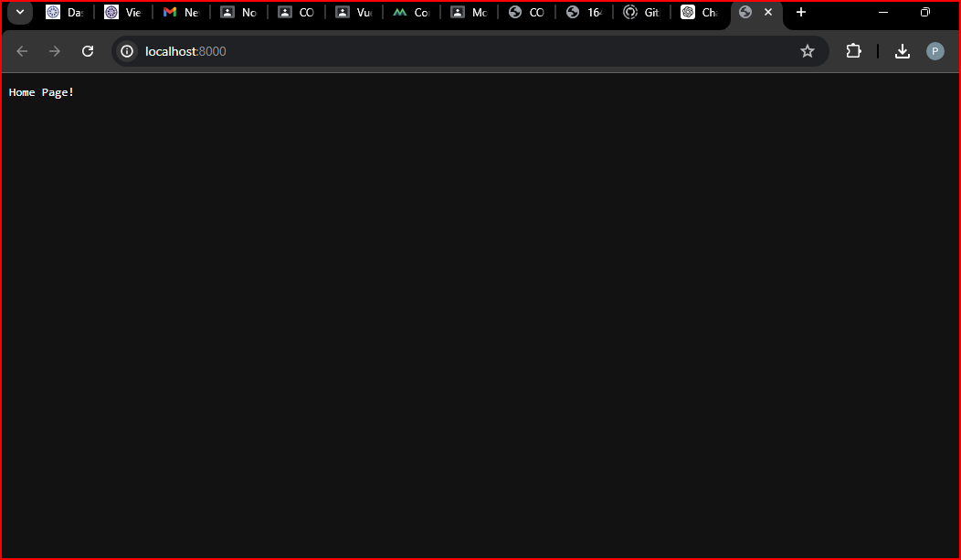

Student Page:

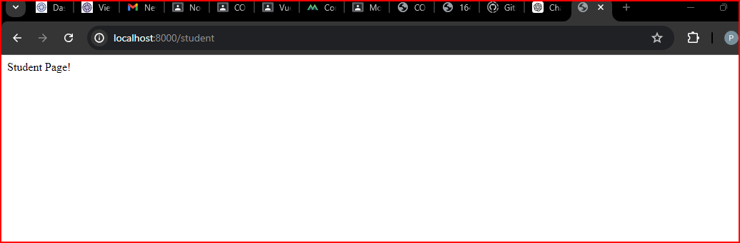

Admin Page:

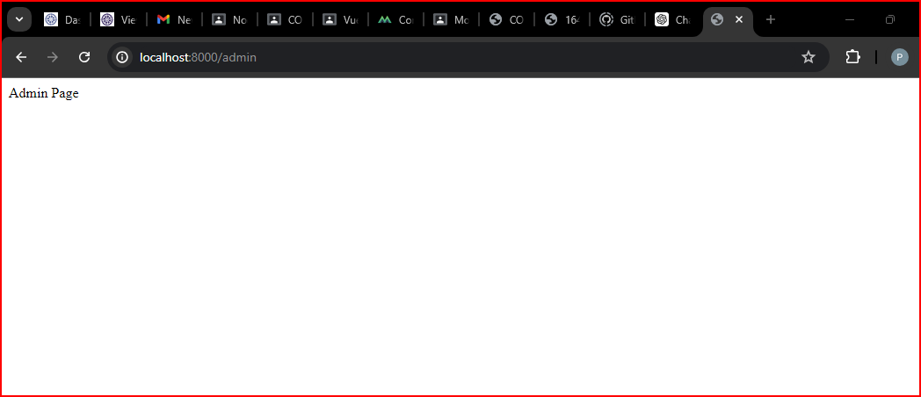

Data Page:

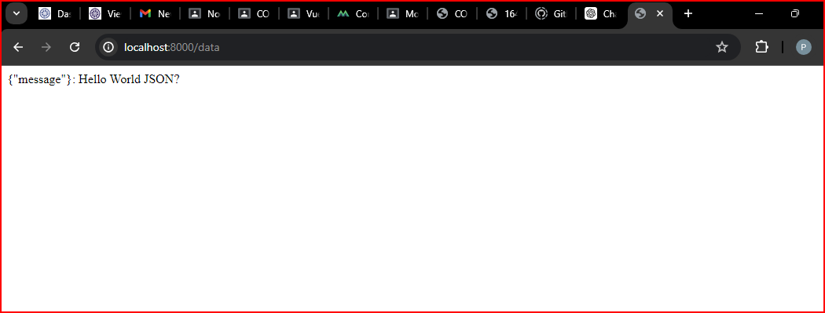

Error Page to catch errors, but hiding error console lines or syntaxes by using a HTML image as a decoy to conceal the presence:

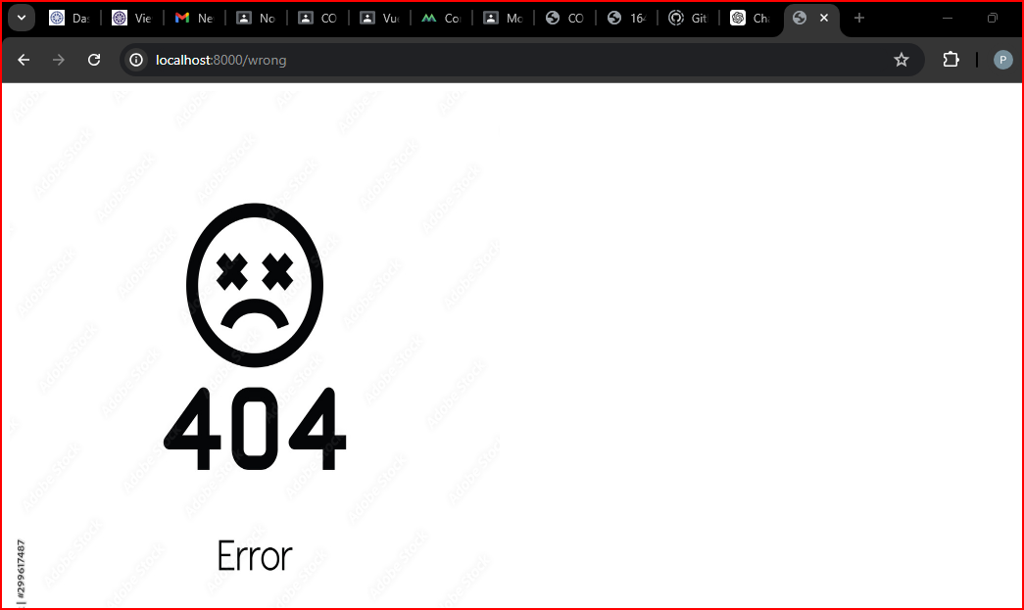

It is always required to have an error page in order not to occurs any error; consequentially, when users are finding certain or wrong keyword on the link bar, the next part is to be redirected at the configured error page – a notification to let user know that search incorrectly.